PHASE 5 PART B
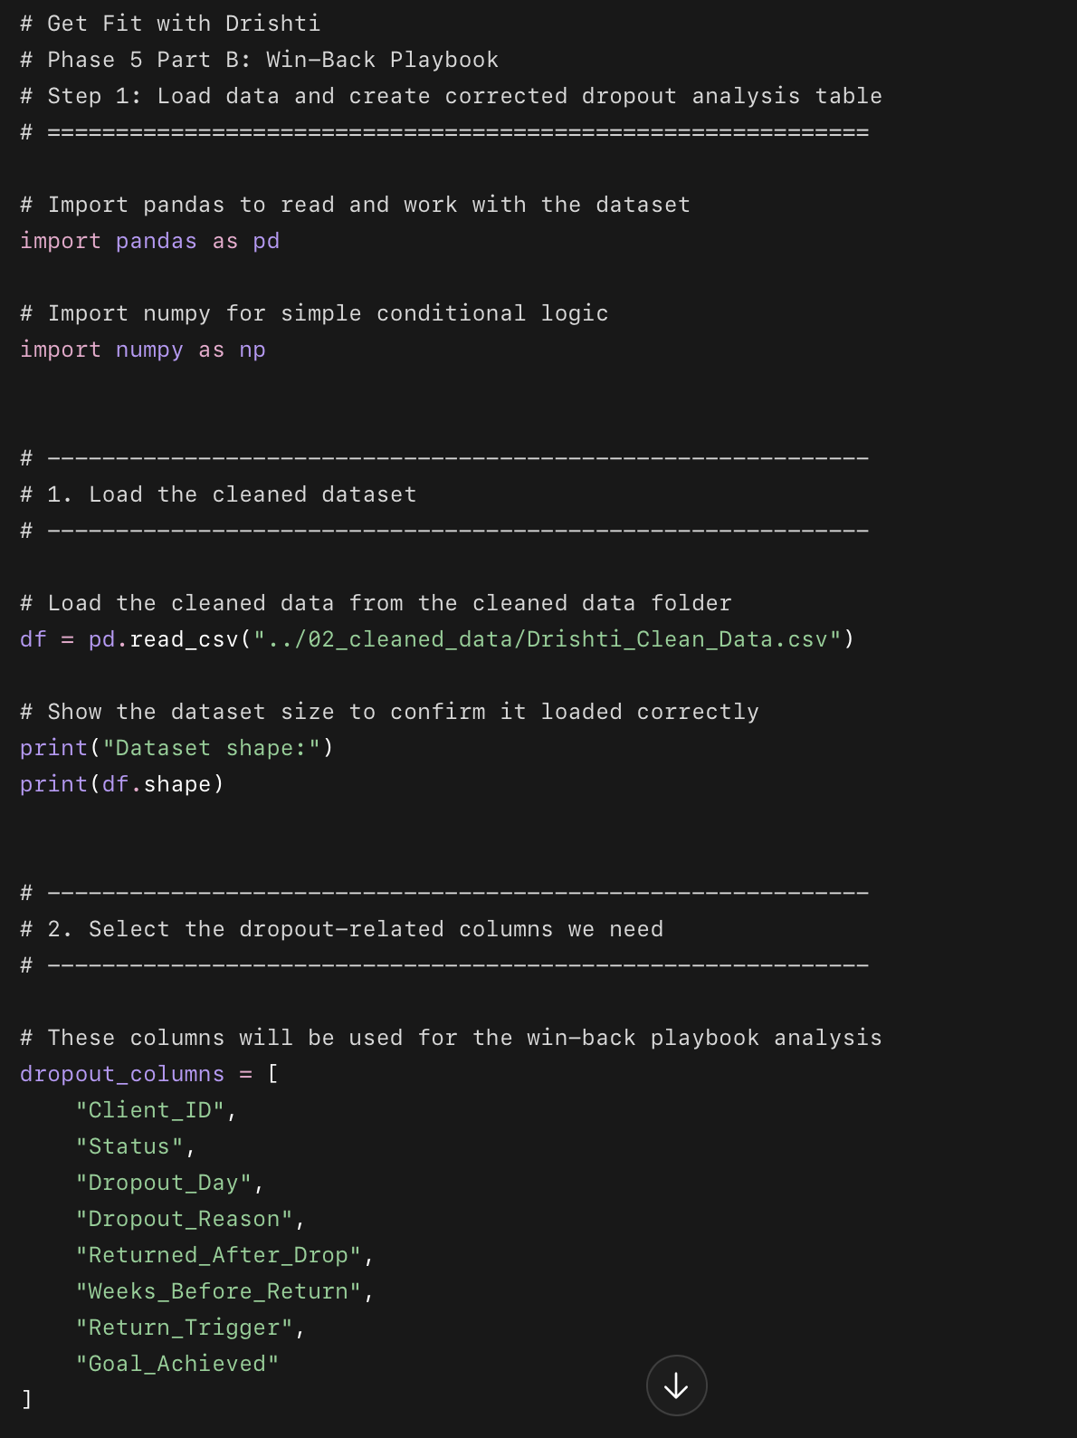
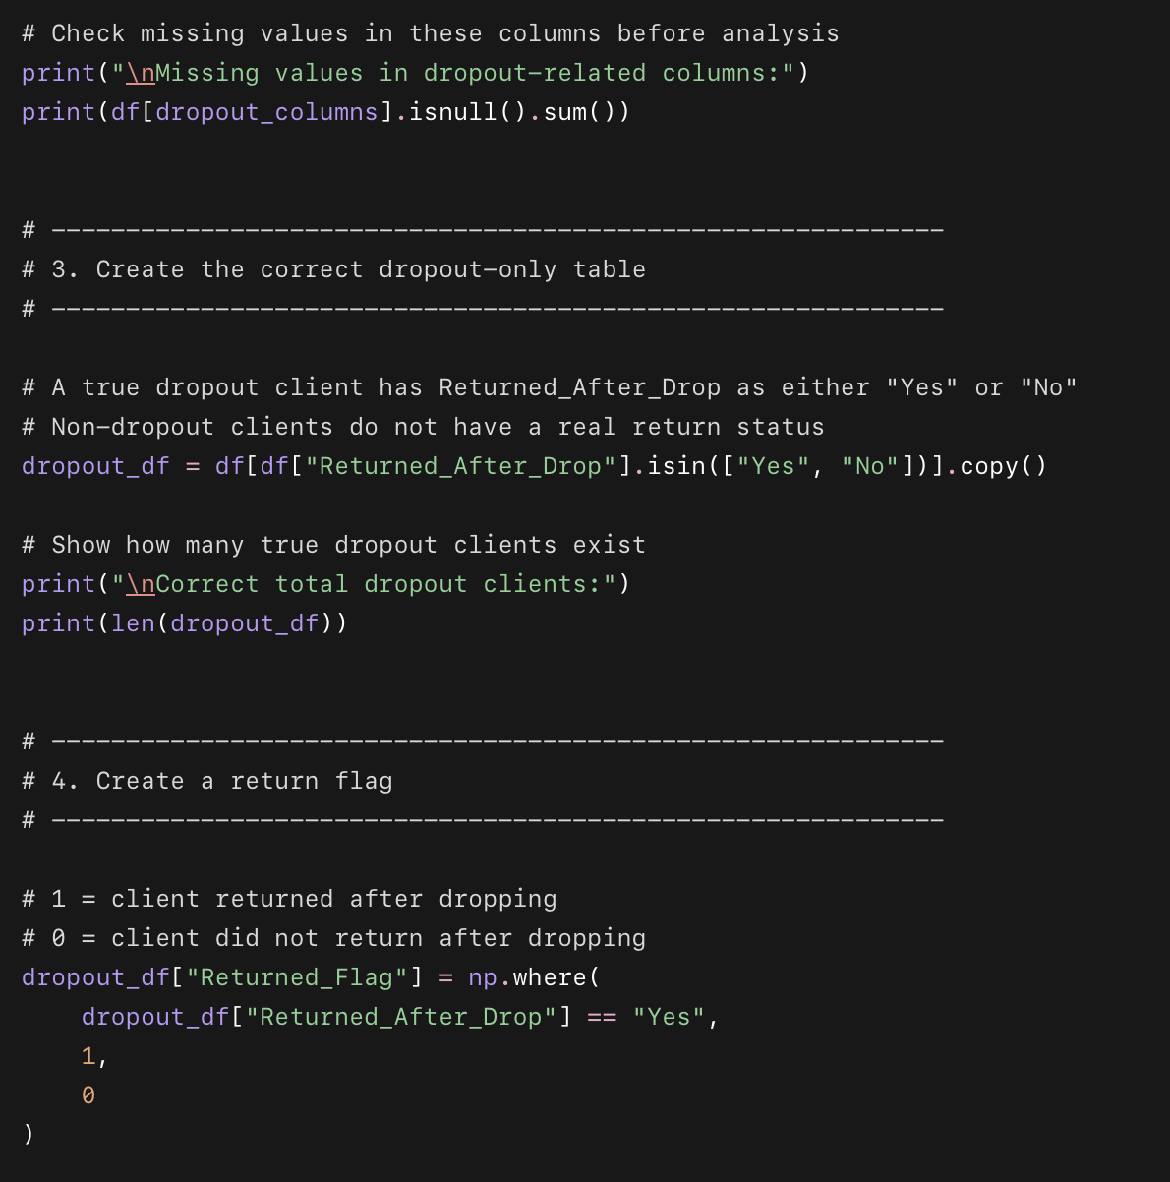
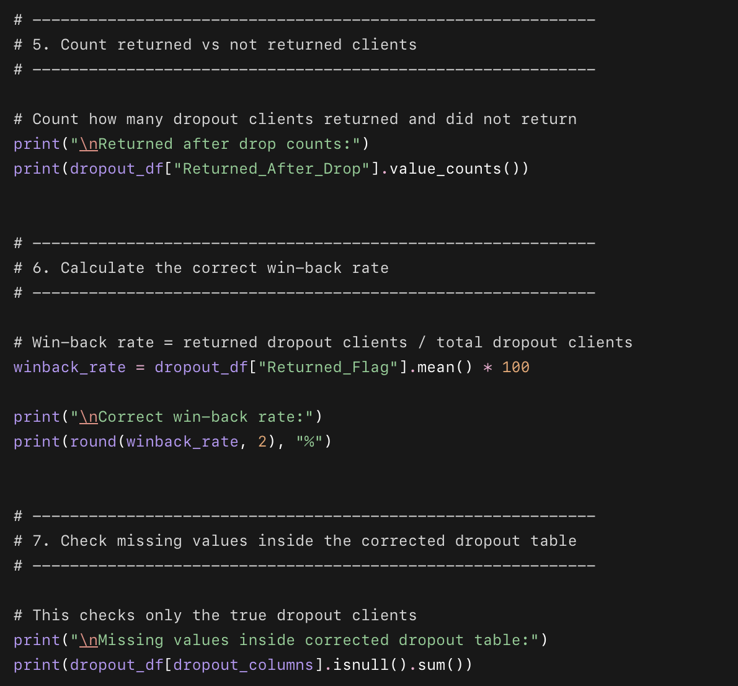
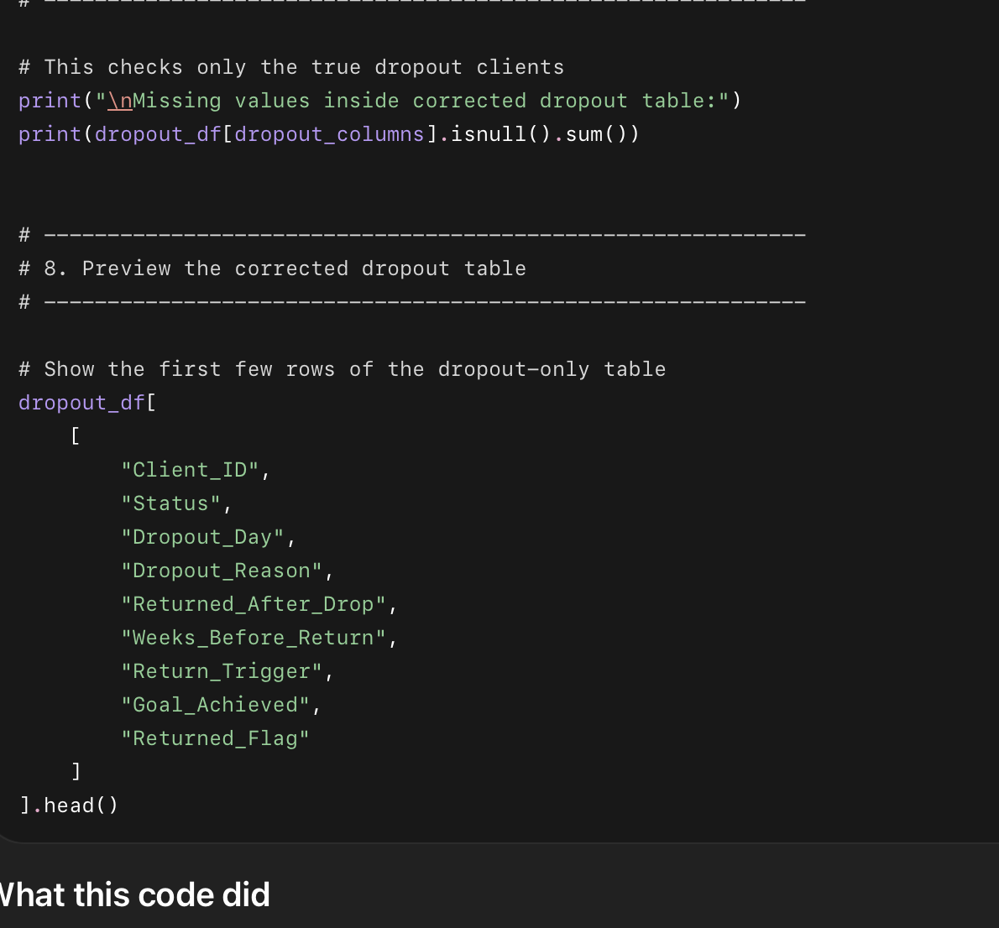

What this code did
- Loaded the cleaned dataset from the 02_cleaned_data folder.
- Checked the size of the dataset to make sure the file loaded correctly.
- Selected the important dropout and return columns needed for the win-back analysis.
- Checked missing values in those columns.
- Created a corrected dropout_df table with only real dropout clients.
- Used Returned_After_Drop instead of Dropout_Day because your cleaned data has Dropout_Day = 0 for non-dropout clients.
- Created Returned_Flag:
  - 1 = client returned after dropping.
  - 0 = client did not return.
- Counted how many dropout clients returned vs did not return.
- Calculated the correct win-back rate.
- Previewed the final dropout-only table.

Why we used this code
We need a clean dropout-only dataset before building the win-back playbook. This step makes sure we are analyzing only clients who actually dropped out, not all 3,000 clients. Without this correction, the return rate and win-back analysis would be wrong.
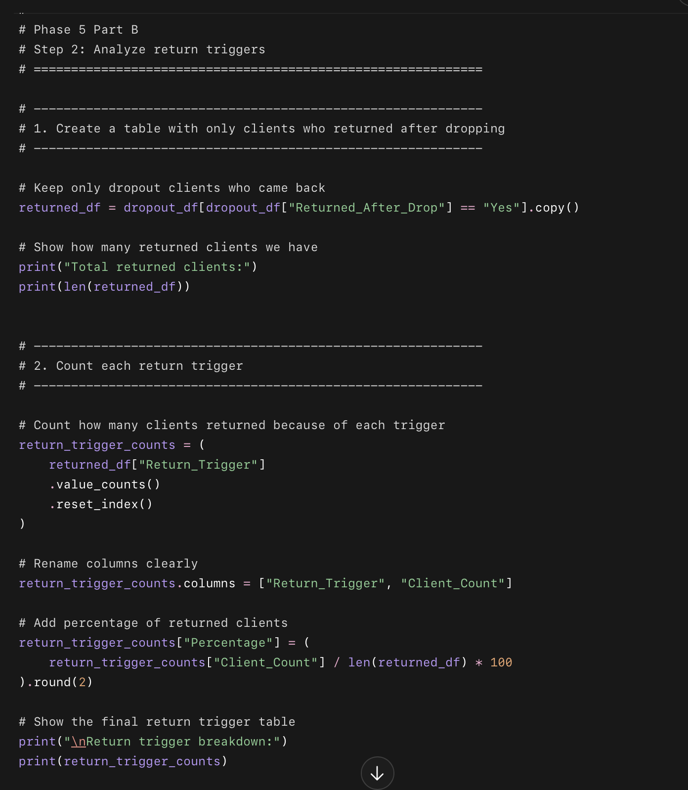
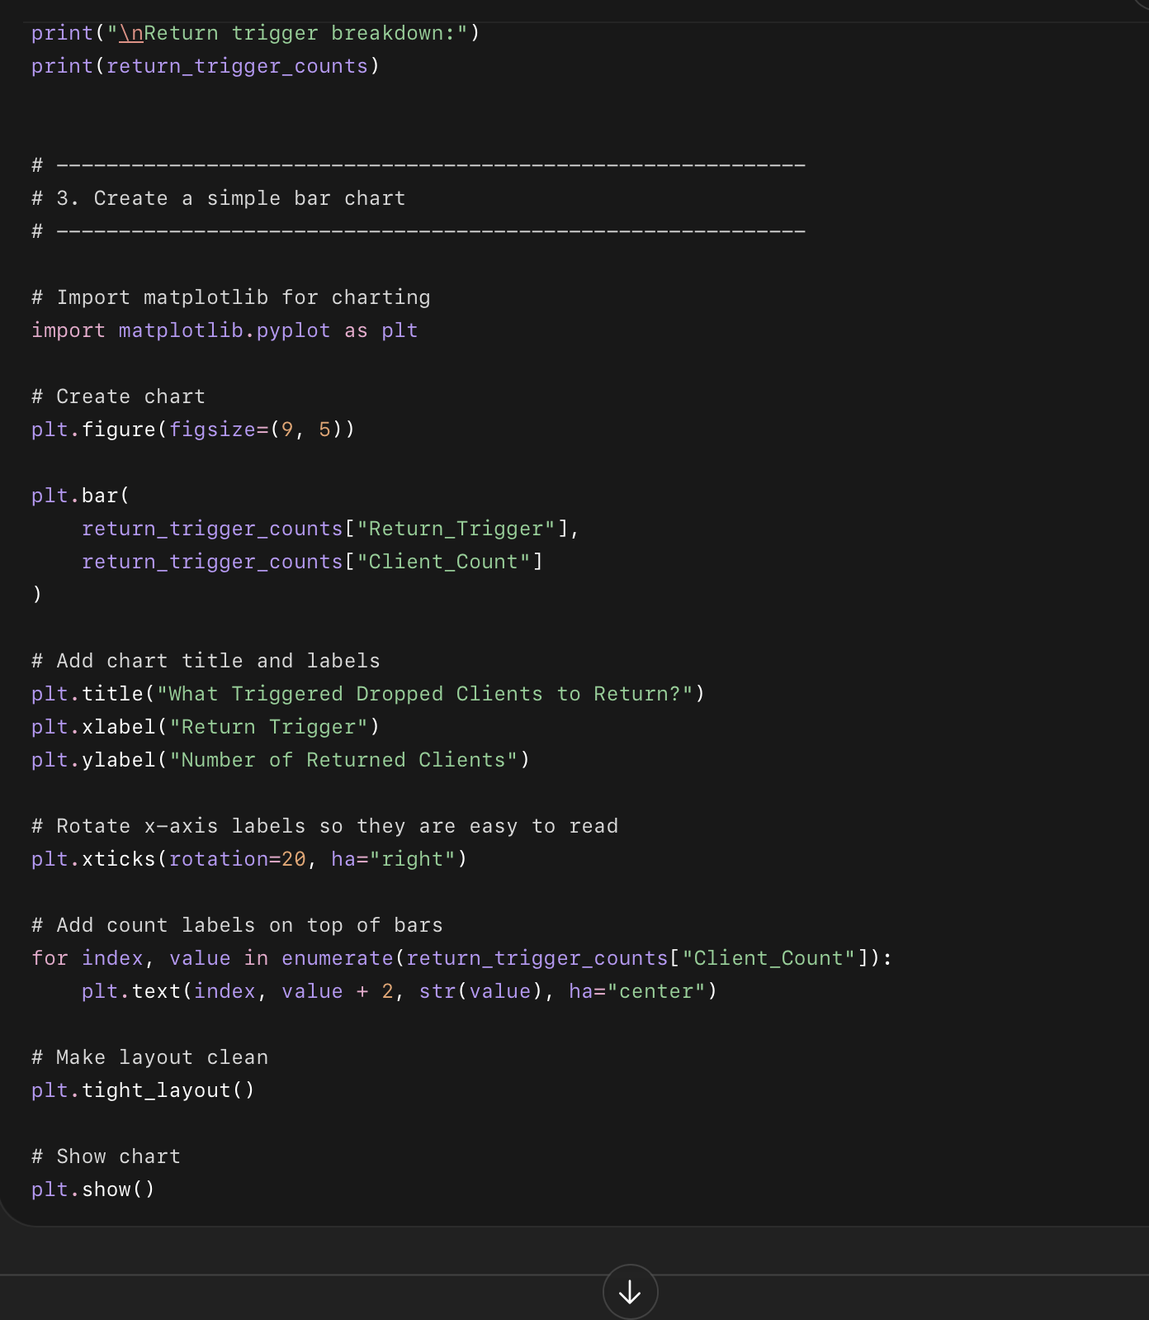

What this code does
- Creates returned_df, which includes only clients who dropped out and later returned.
- Counts how many clients returned because they:
  - saw other clients’ progress
  - had a personal motivation reset
- Calculates the percentage share of each return trigger.
- Creates a simple bar chart showing the most common reason clients came back.

Why we used this code
This tells Drishti what actually pulls dropped clients back into the program. If most clients return after seeing other clients’ progress, then social proof, testimonials, progress photos, and success stories should be part of the win-back strategy.

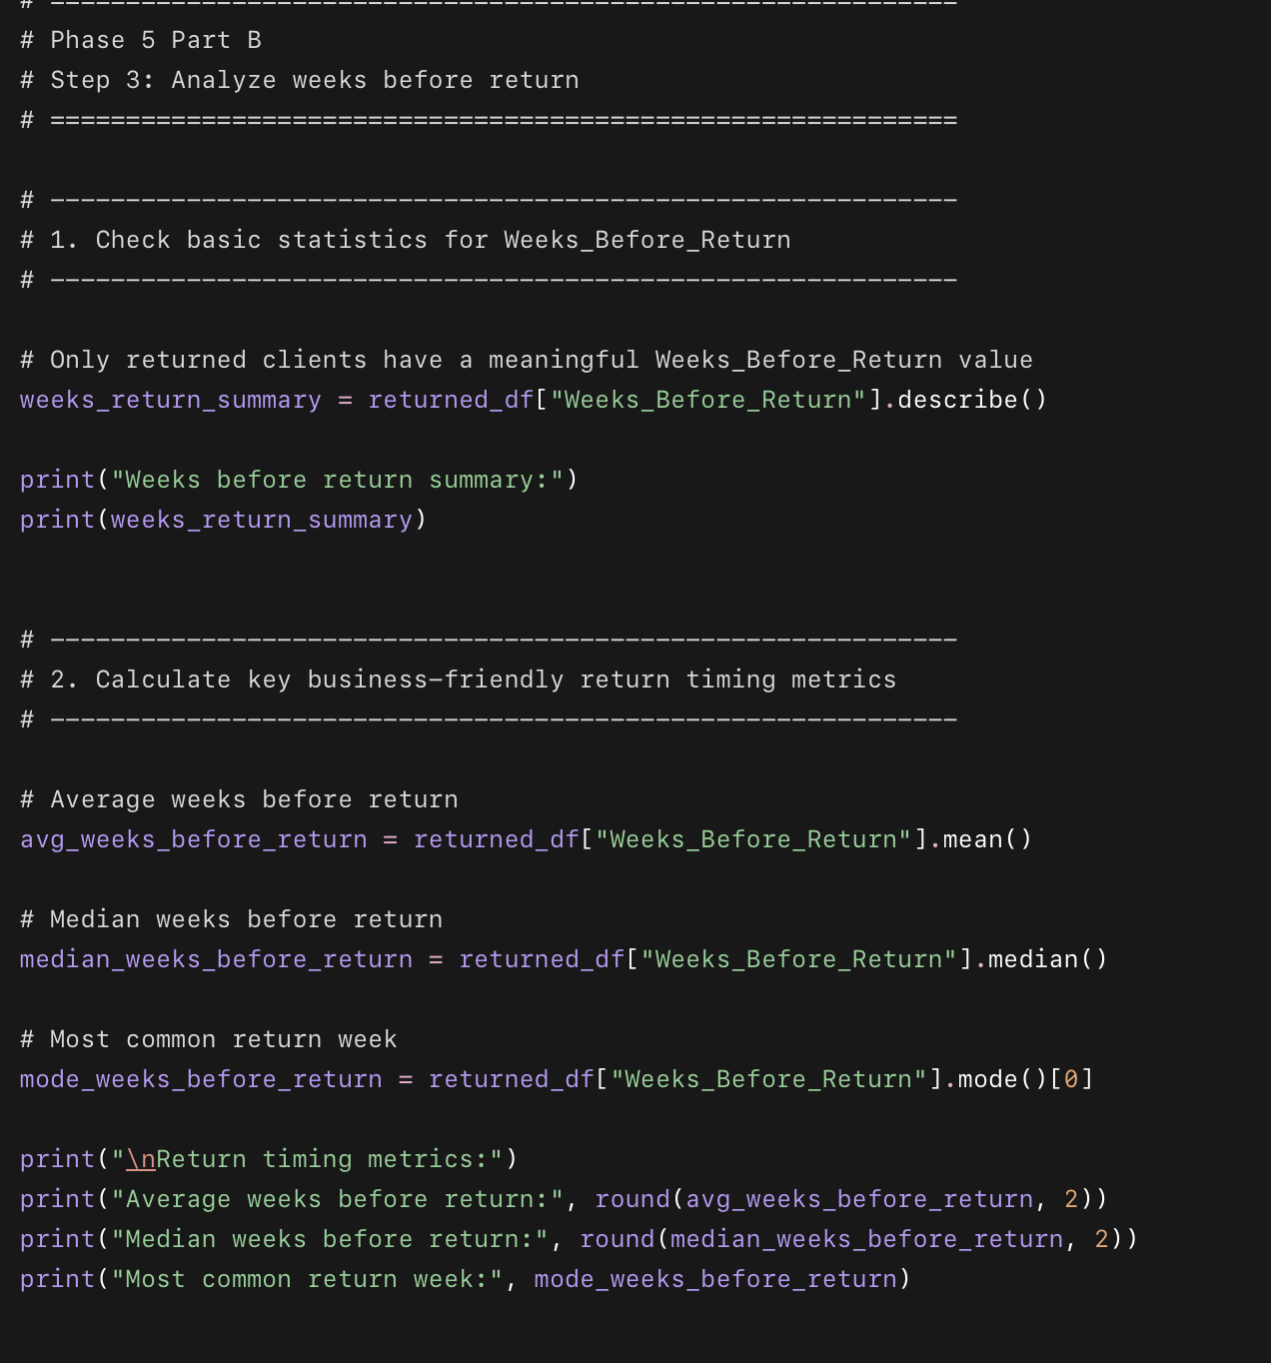
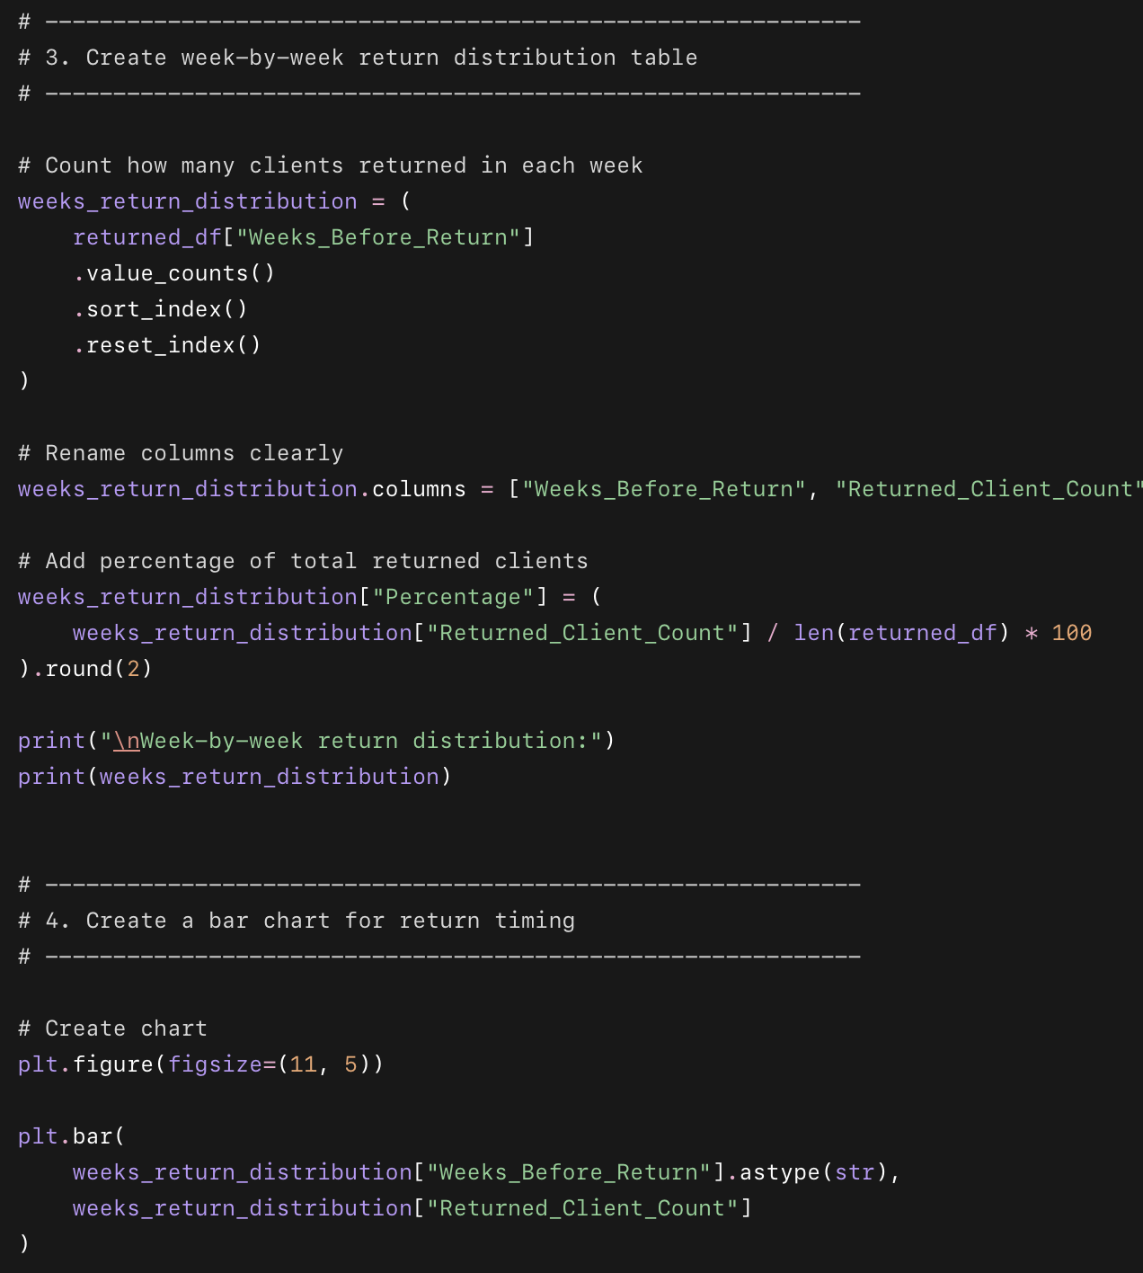
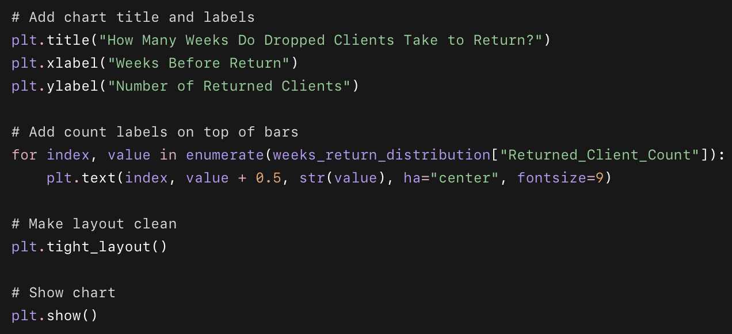

What this code does
- Looks only at clients who returned after dropping.
- Summarizes Weeks_Before_Return.
- Calculates:
  - average return time
  - median return time
  - most common return week
- Counts how many clients returned in each week.
- Creates a bar chart showing the return timing pattern.

Why we used this code
This helps Drishti understand the best follow-up timing. If many clients return within a certain number of weeks, she can create a structured follow-up schedule instead of randomly messaging clients.

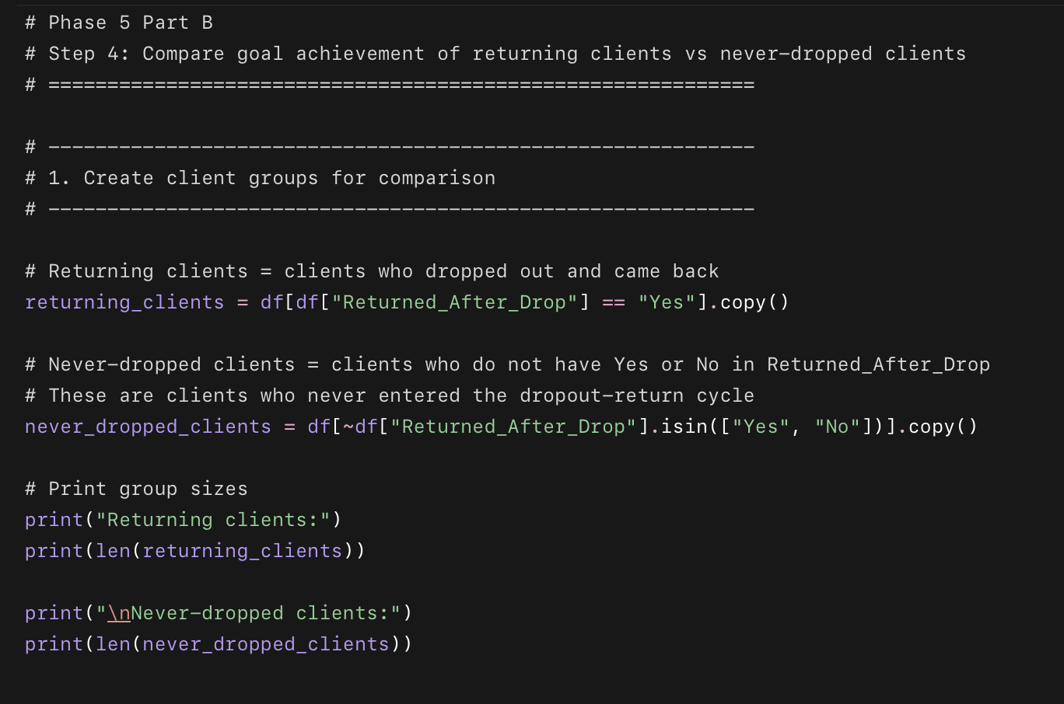
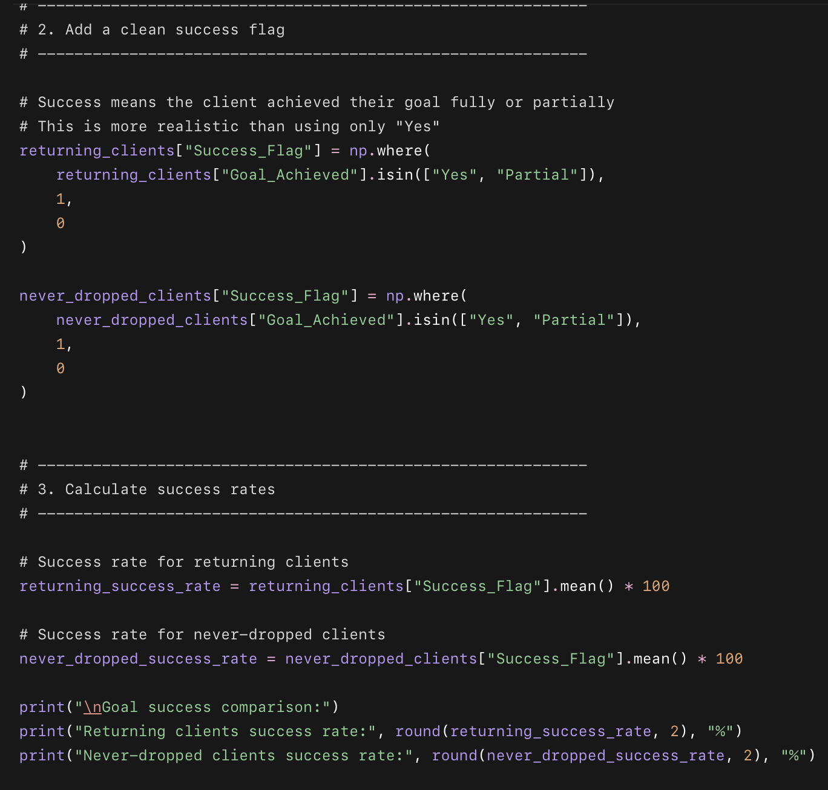
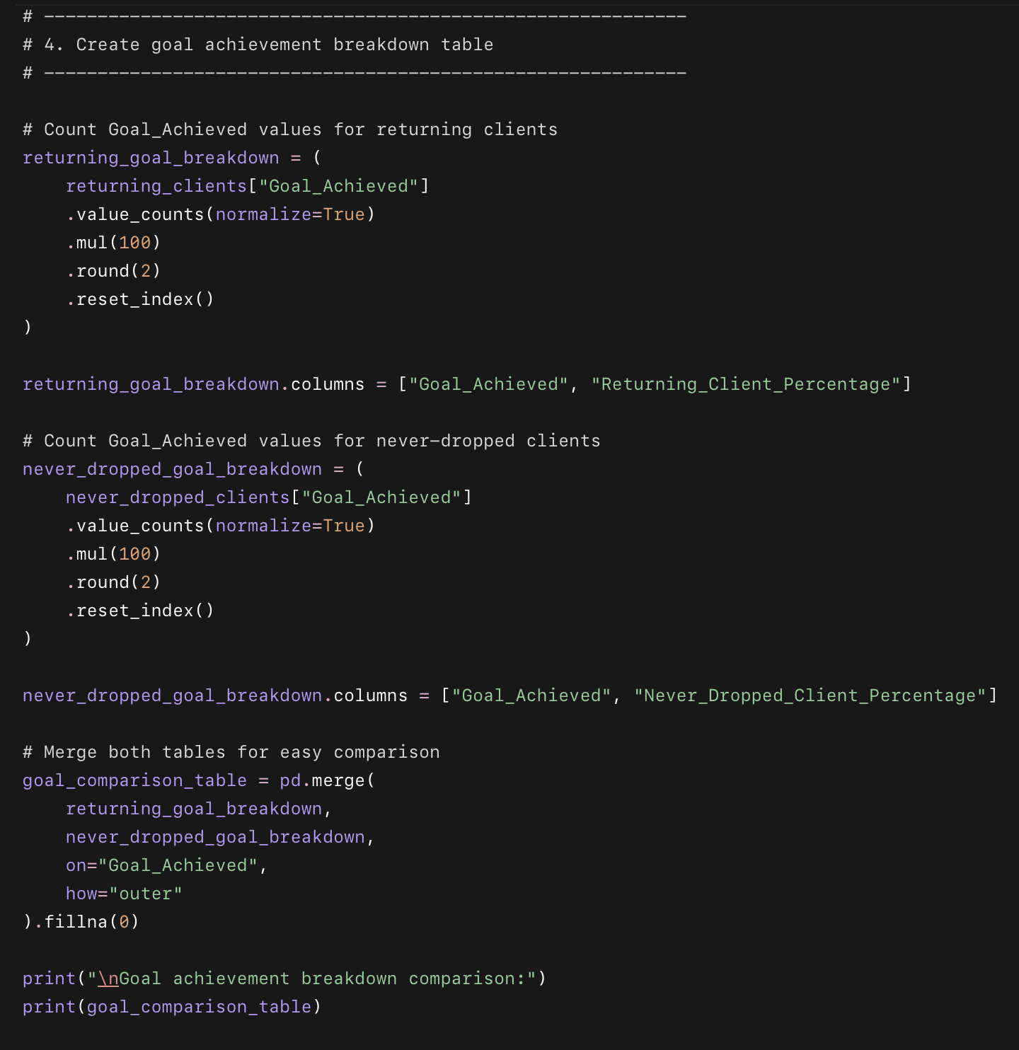
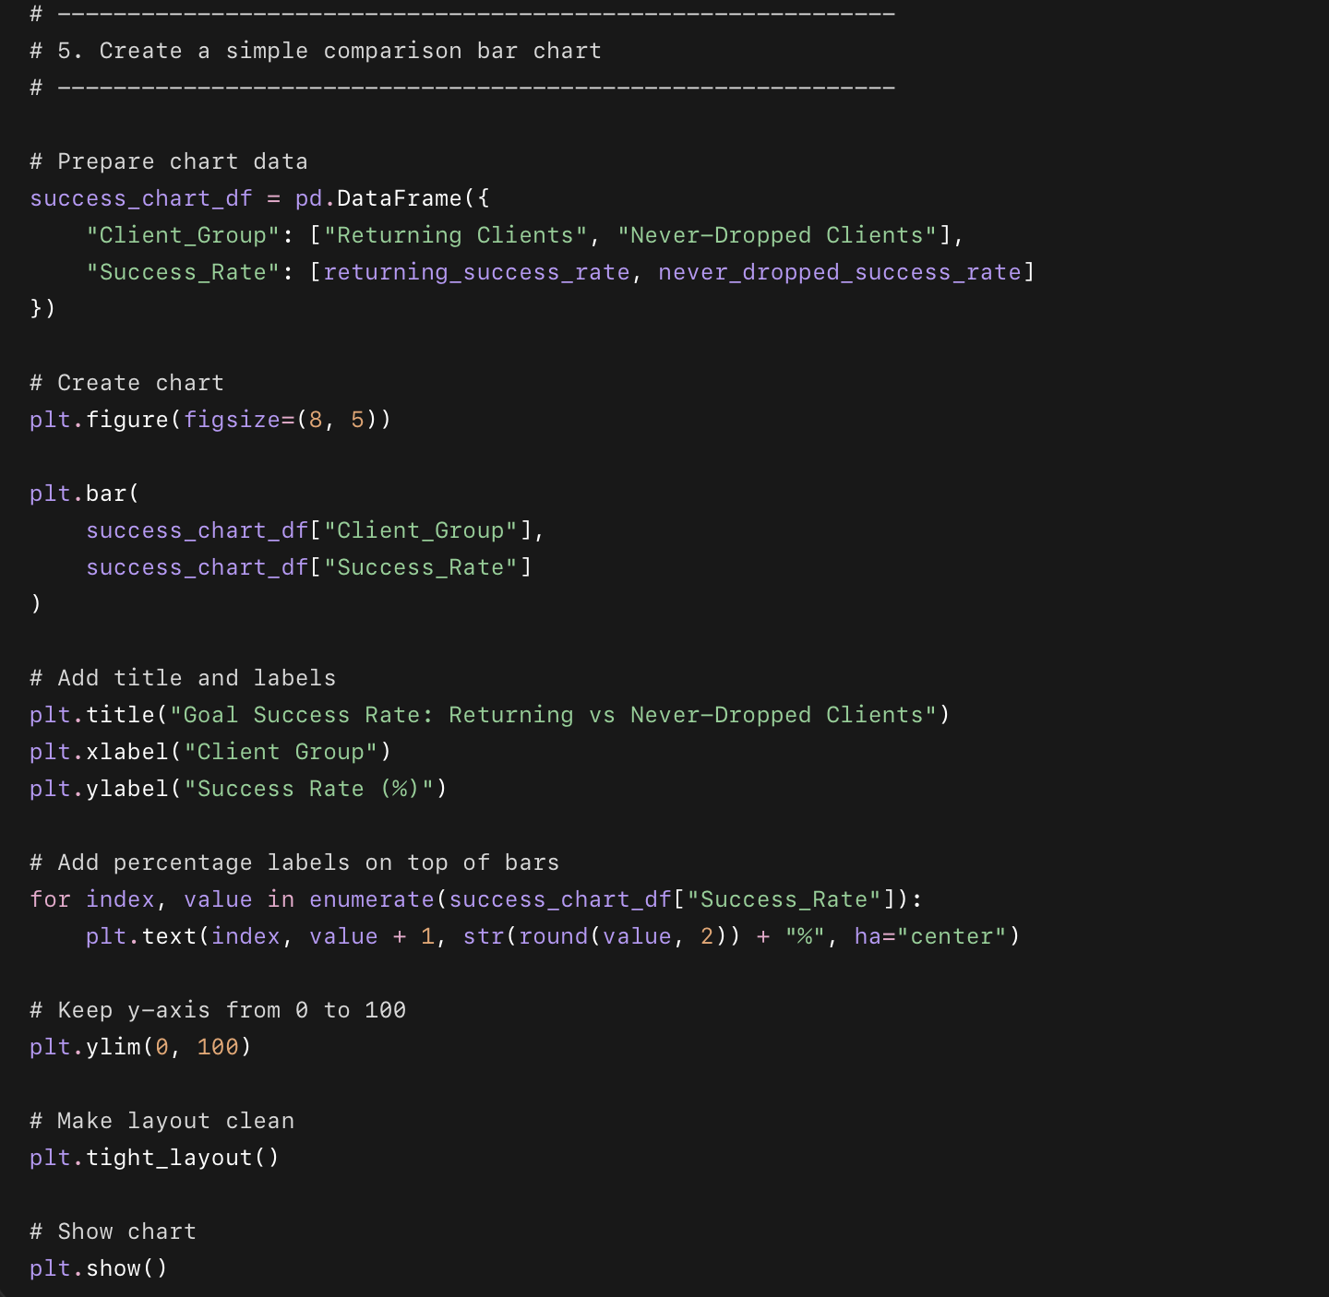

What this code does
- Creates two groups:
  - returning clients
  - never-dropped clients
- Defines success as Goal_Achieved = Yes or Partial
- Calculates success rate for both groups
- Builds a goal achievement comparison table
- Creates a bar chart comparing success rates

Why we used this code
This shows whether win-back clients are still worth investing time in. If returning clients still achieve goals at a decent rate, then follow-up is valuable for both client experience and business reputation.

result is very suspicious and important.
It says:
Returning clients success rate: 0.0%
Never-dropped clients success rate: 90.81%
And the table says 100% of returning clients have Goal_Achieved = No.
That means one of two things:
- Business/data meaning: clients returned, but the dataset still records their final goal result as “No.”
- Data limitation/problem: the dataset may not properly update Goal_Achieved after a client returns.
Before we write the final Step 4 conclusion, we should quickly validate this.
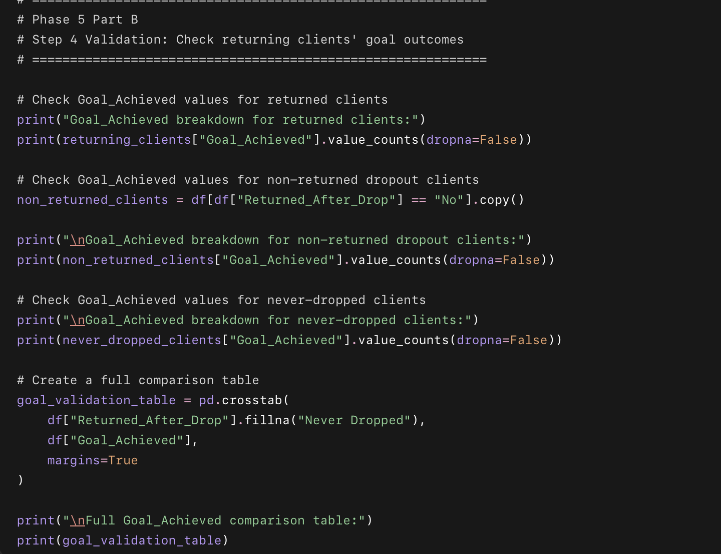

What this validation code does
- Checks whether all returned clients really have Goal_Achieved = No.
- Compares returned clients, non-returned dropout clients, and never-dropped clients.
- Creates a full cross-tab table so we can confirm whether this is a real pattern or a data issue.

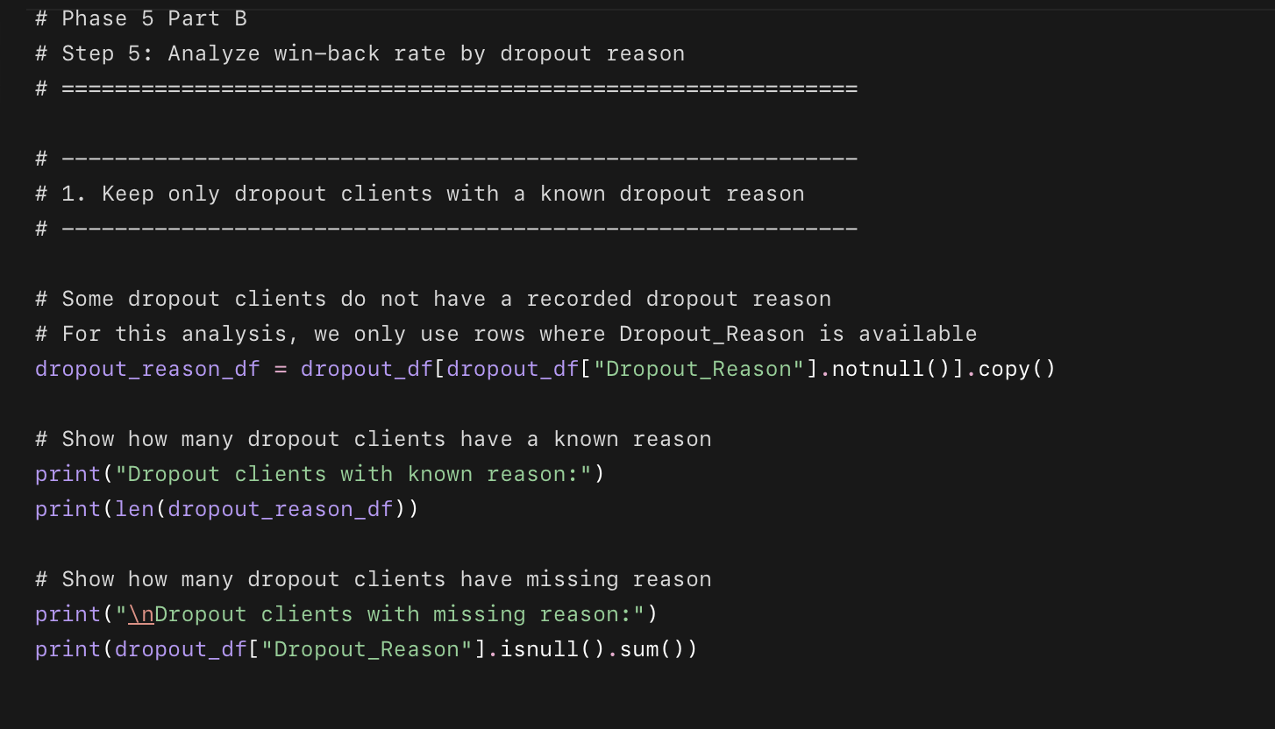
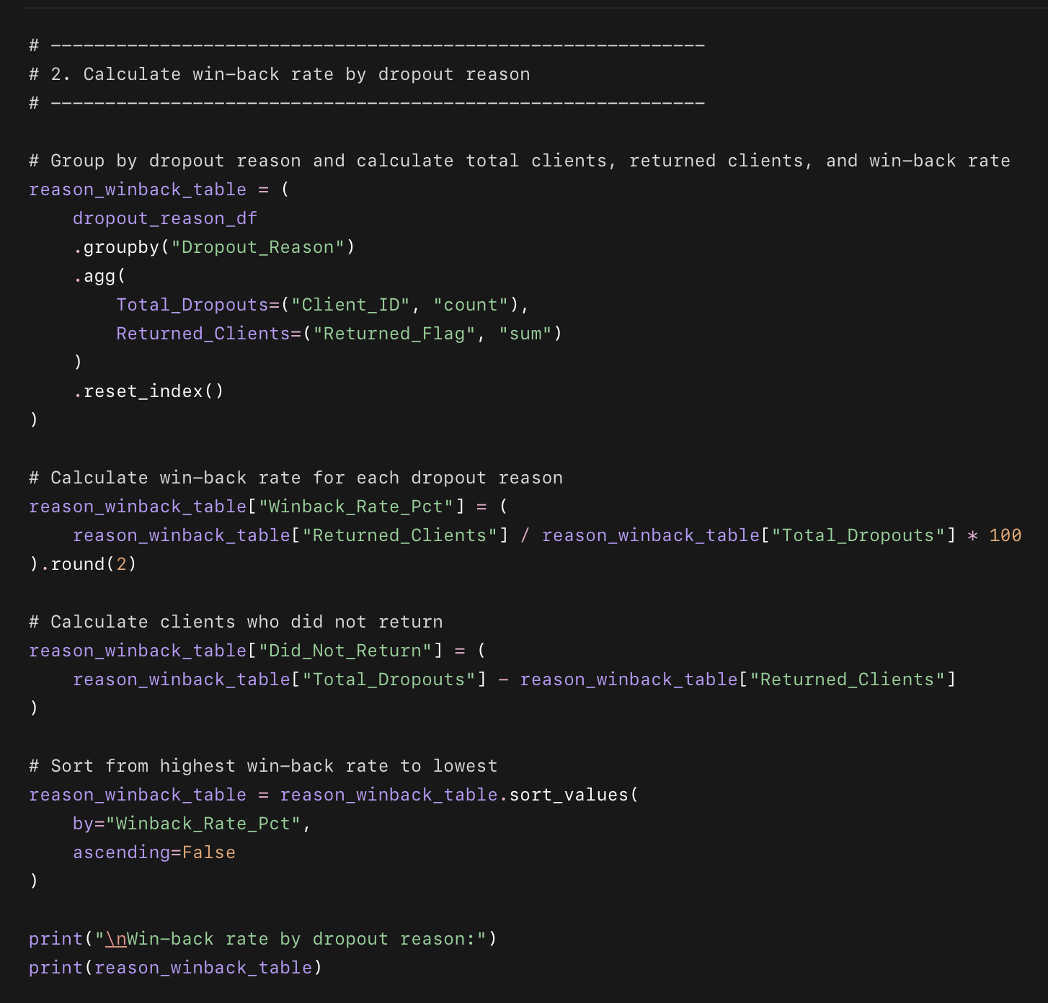
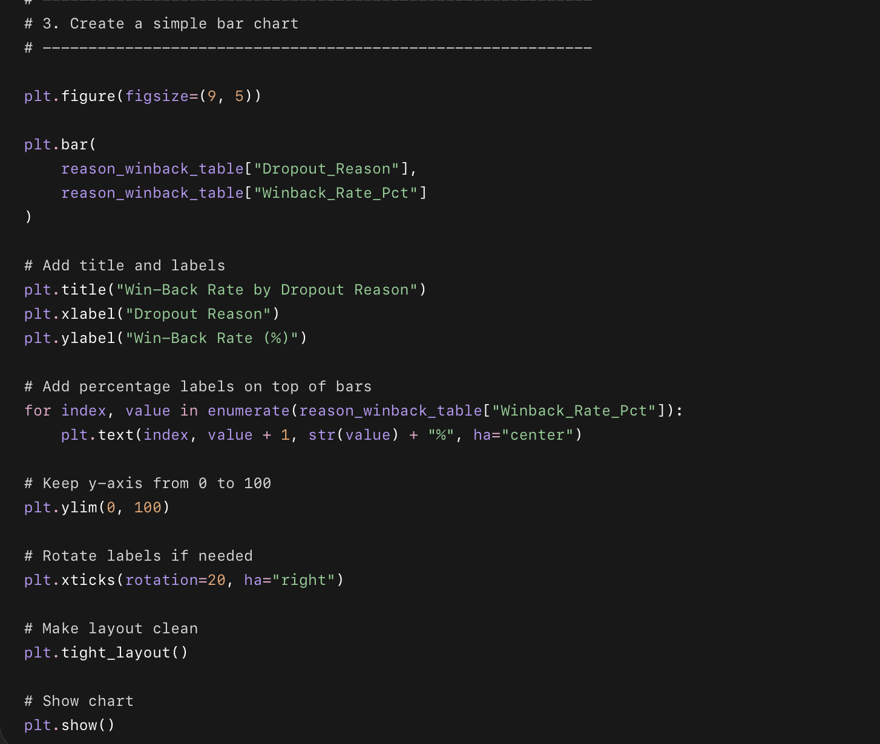

What this code does
- Creates a smaller table with only dropout clients who have a known dropout reason.
- Counts total dropouts for each reason.
- Counts how many of those clients returned.
- Calculates the win-back rate for each reason.
- Shows which dropout reason has the highest chance of return.
- Creates a bar chart to make the comparison easy to understand.

Why we used this code
This helps Drishti decide how to follow up based on why the client dropped out.
For example:
- If “Busy Schedule” has a high win-back rate, the message should focus on making the plan easier and more flexible.
- If “Laziness” has a lower rate, the message should focus more on motivation, accountability, and small wins.
- If “Health Issue” has a high or low rate, the message should be more supportive and careful.
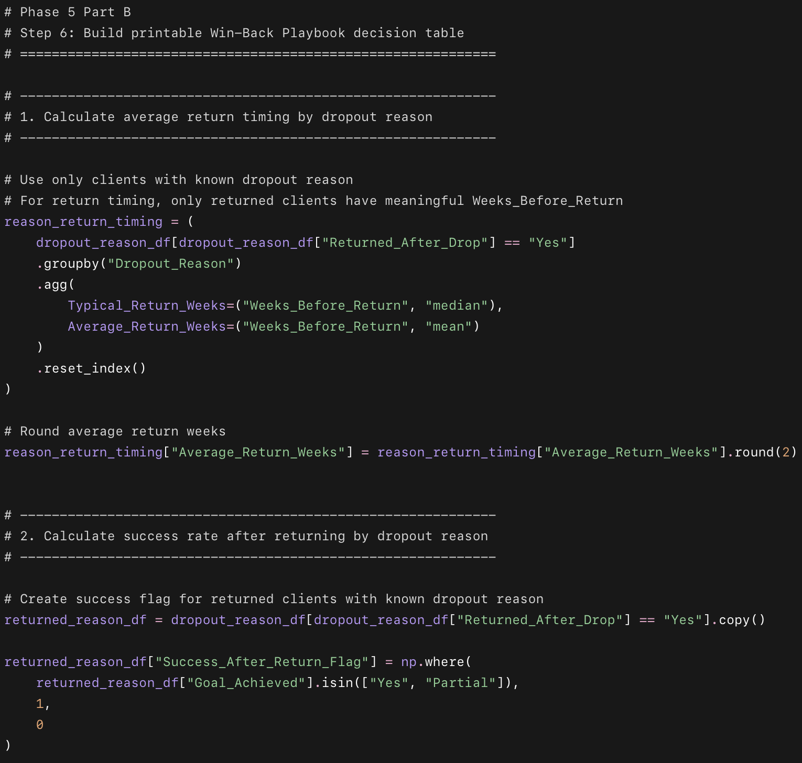
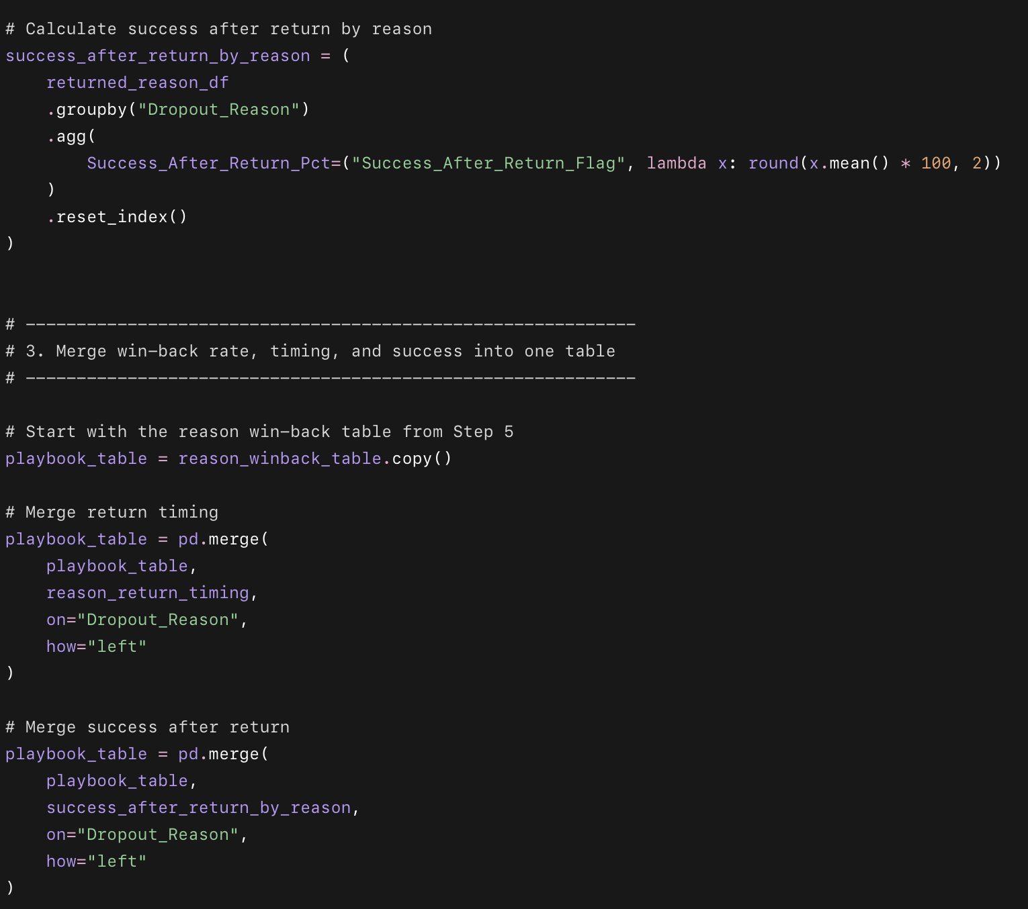
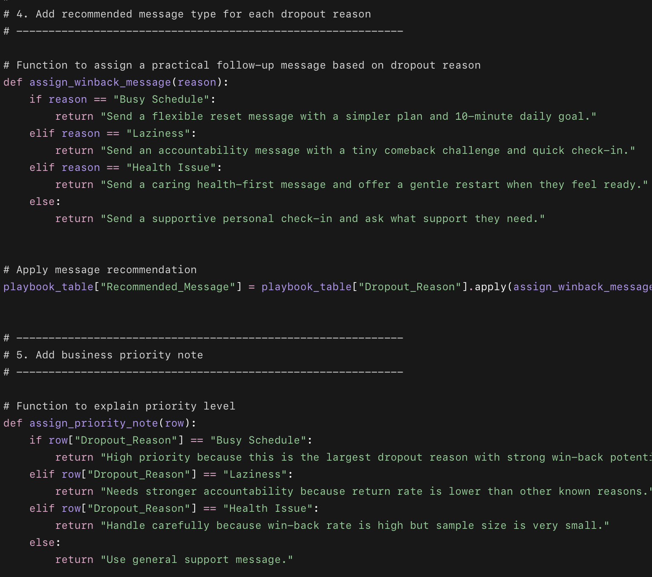
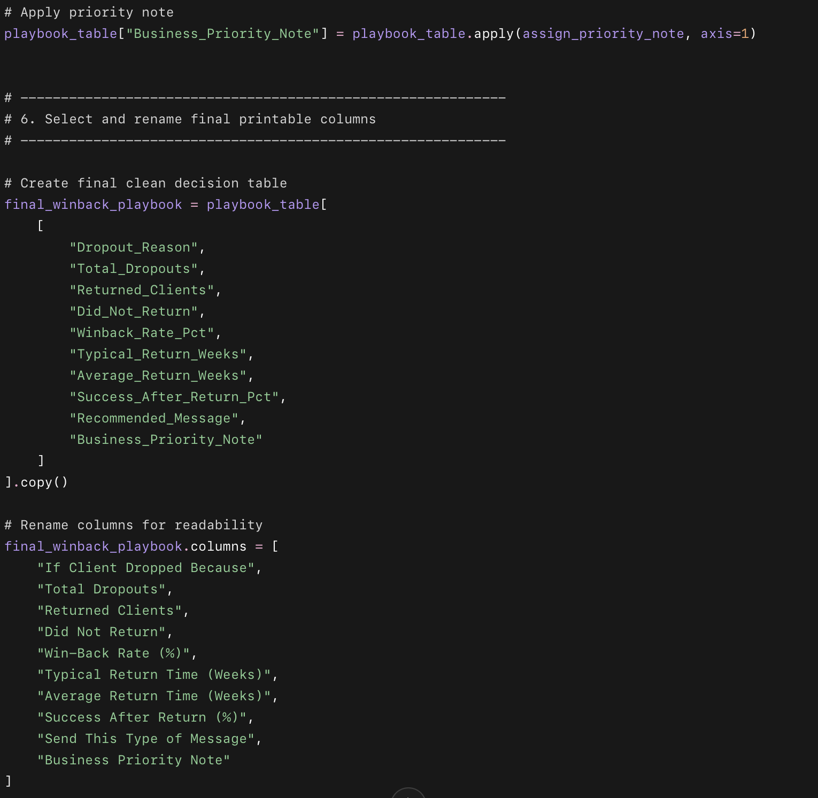
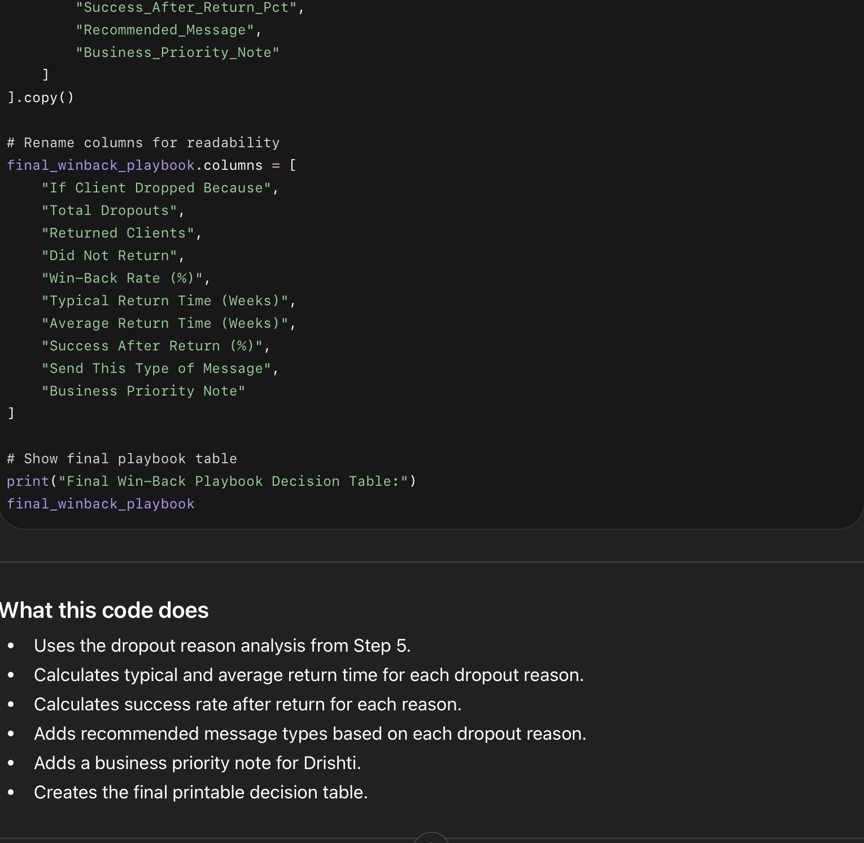

What this code does
- Uses the dropout reason analysis from Step 5.
- Calculates typical and average return time for each dropout reason.
- Calculates success rate after return for each reason.
- Adds recommended message types based on each dropout reason.
- Adds a business priority note for Drishti.
- Creates the final printable decision table.

Why we used this code
This turns the analysis into a real business tool. Instead of only showing charts, we create a simple action table that Drishti can use when a client drops out.

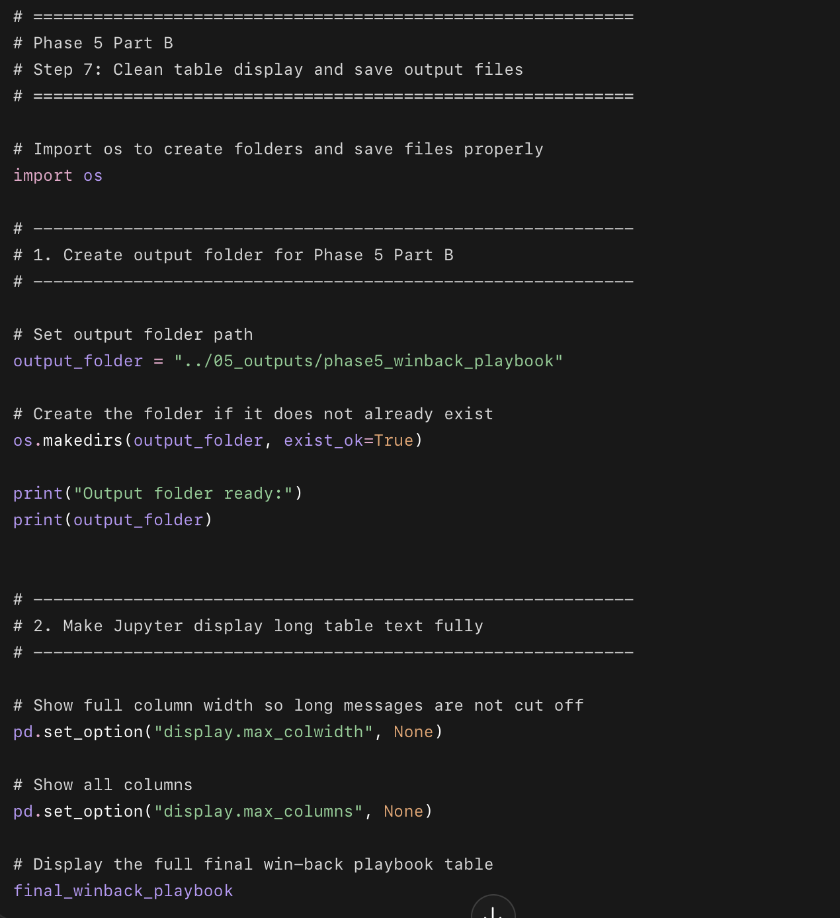
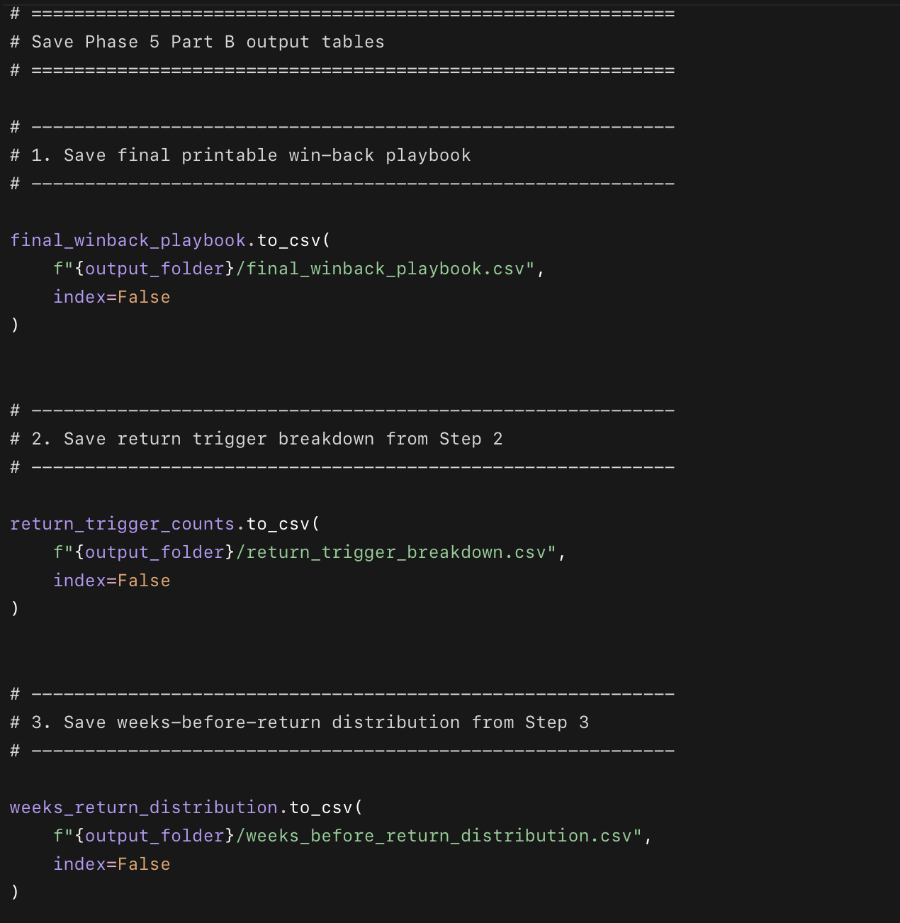
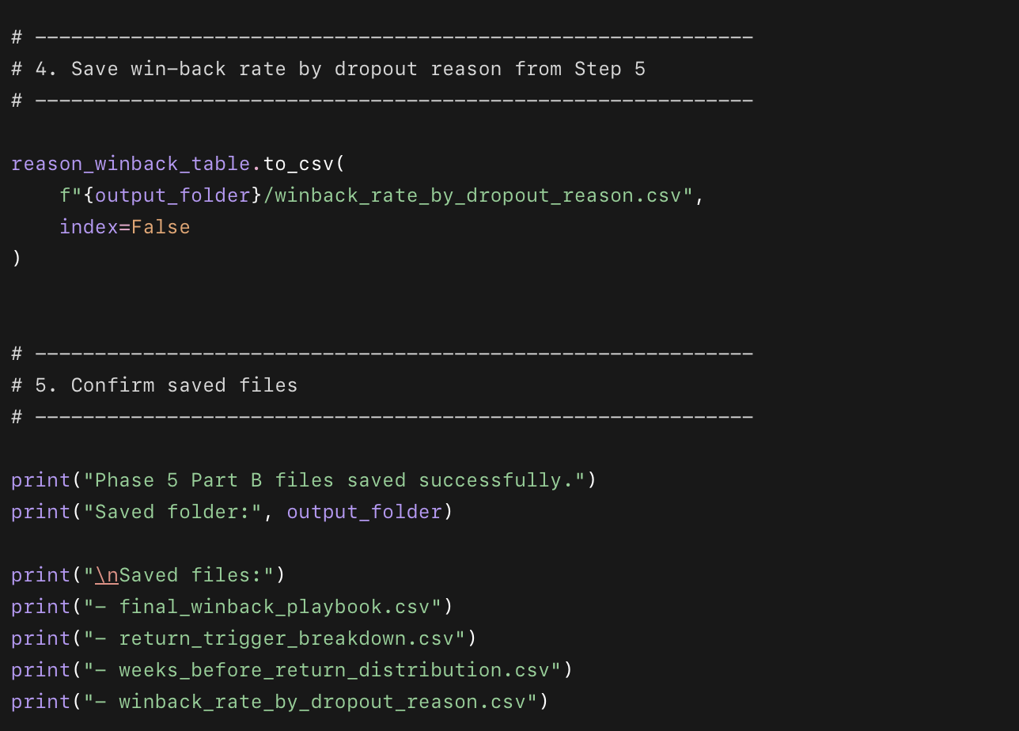

What this code does
- Creates a new folder for Part B outputs.
- Makes the final playbook table easier to read in Jupyter.
- Saves the final decision table as a CSV file.
- Saves the return trigger breakdown.
- Saves the week-by-week return timing table.
- Saves the win-back rate by dropout reason table.
- Confirms that all files were saved successfully.

Why we used this code
This step turns the analysis into saved business files. These files can later be used in Excel, Tableau, reports, portfolio screenshots, and Drishti’s weekly business system.

